PROGRAM – 35, 36, 37

HARINI. R

192324108

35. Write a LEX program to recognise numbers and words in a statement.

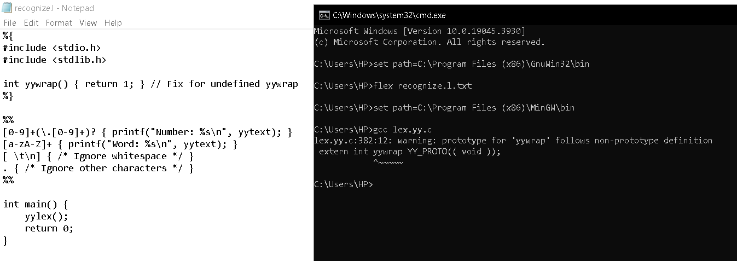

36. Write a LEX program to identify and count positive and negative numbers.

37. Write a LEX program to validate the URL.

